**EGNSS4CAP – Quick Start Guide**

**Implementing Framework Contract**

**GSA/OP/09/16/Lot 2/SC 8**

Table of Contents

Content

Table of Contents 2

1. Mobile application – Android 3

1.1 Getting started 3

1.2 Main menu 3

1.3 Taking a photo 4

1.4 Tracking a path 5

1.5 Taking a photo using fake GNSS 5

2. Mobile application – iOS 6

2.1 Getting started 6

2.2 Main menu 6

2.3 Taking a photo 6

2.4 Tracking a path 7

3. Web Interface 9

3.1 Getting started 9

3.2 User (farmer) interface 9

3.3 Administrator (Paying Agency) interface 10

3.3.1 User management 10

3.3.2 Task management 10

# Mobile application – Android

This Quick Start Guide provides a brief overview of the main functionalities of the EGNSS4CAP Android application. Detailed information on the functionalities of the application can be found in the EGNSS4CAP User Manual.

## Getting started

* The EGNSS4CAP application is distributed by the Google Play Store:

<https://play.google.com/store/apps/details?id=eu.foxcom.gtphotos>

* Make sure to grant permissions to access the device’s location, take pictures and record video, and make and manage phone calls:
  + Access device’s location
    - Allow to add location data to token photos.
    - Receiving different types of location data
    - Recording paths.
  + Take pictures and record video
    - Allow to take photos by camera.
  + Make and manage phone calls
    - Allow to assign data about mobile or Wi-Fi network with token photos
* To log in to the application, connection to the internet is required. After the first login, the user will be remembered. A new login will only be required after explicit logout.

## Main menu

On the main screen, information on the user’s device is shown, including the capability to receive location data and read GNSS parameters. If any of the traffic lights are red or yellow, the device does not have the indicated capability.

The application modules can be accessed through by pressing the 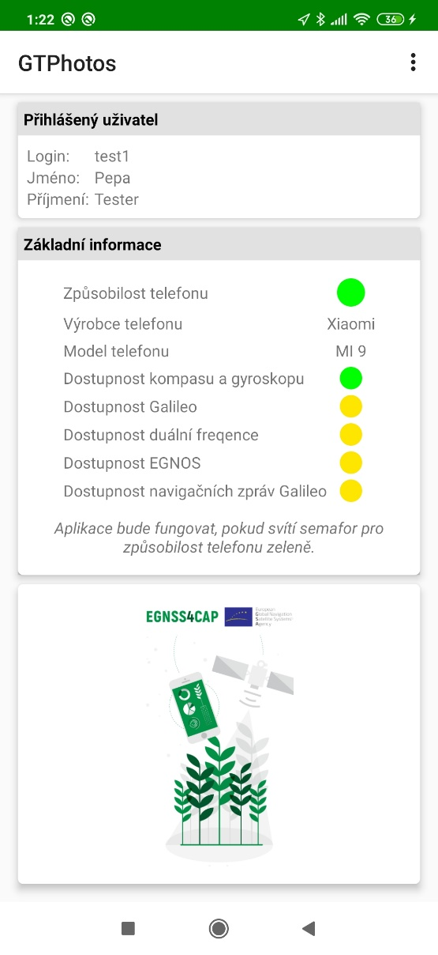 button which is situated in the right upper corner of the screen. In this menu the following options are available:

* Synchronize
  + Start synchronization process with server. During synchronization the application is not available to use and connection to internet is necessary.
* Task Overview
  + Open screen with task list.
* Unassigned Photos
  + Open screen with list of unowned photos.
* Map
  + Open screen with map including all captured photos.
* Path Tracking
  + Open screen with map for recording new paths or viewing already recorded paths.
* Settings
  + Open screen with settings.
* GNSS Raw Data
  + Open screen with overview of currently receiving GNSS data.
* About
  + Open screen with basic information about application
* Logout
  + Logout user and show *Login screen.*

## Taking a photo

In task overview (Image 1 Task Overview) the user can see their tasks by names, statuses, number of photos, date of creation and due date. By clicking on the task row, the task completion screen is opened.

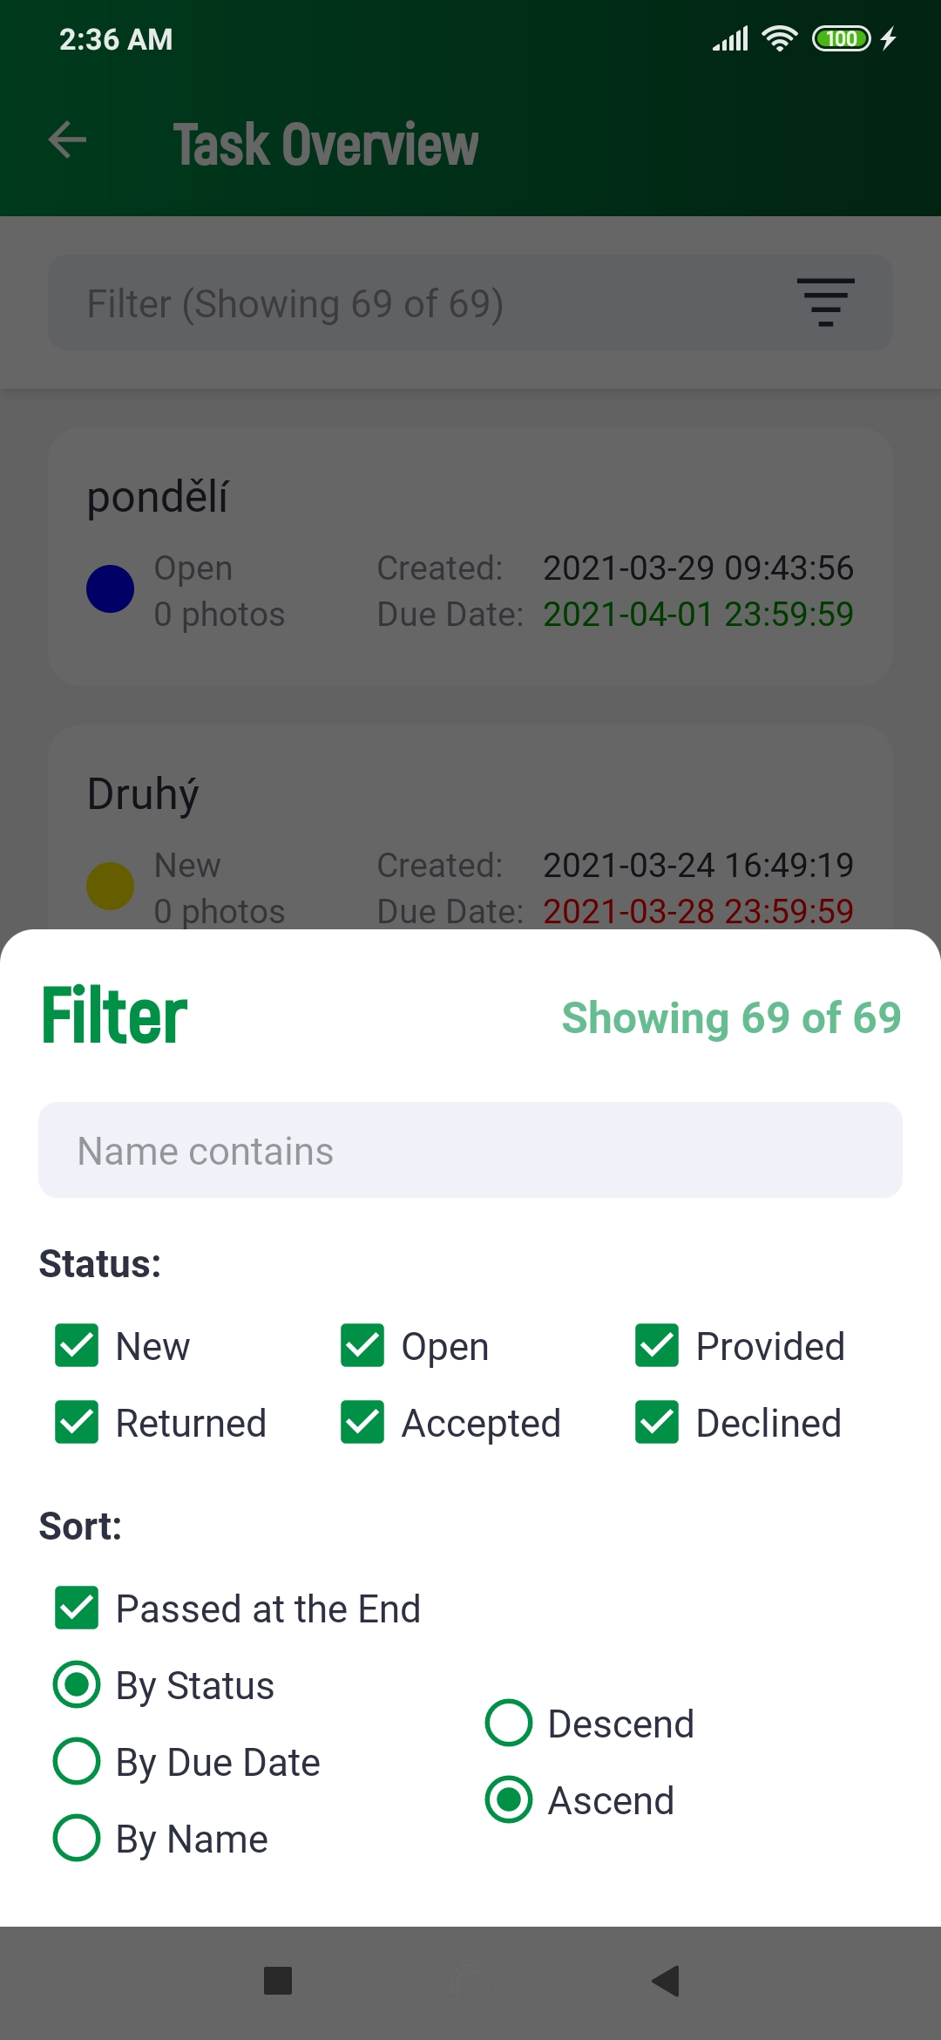

Image 1 Task Overview

When clicking on a task, the user will be directed to the Task Completion screen. For each task, the Paying Agency administrator can give *Instructions*, indicate a *Reason for Return* if the task has been returned to the user for additional information.

The user can provide the Paying Agency with information in the *Note* section.

Users can take a geotagged photo by clicking on the camera button 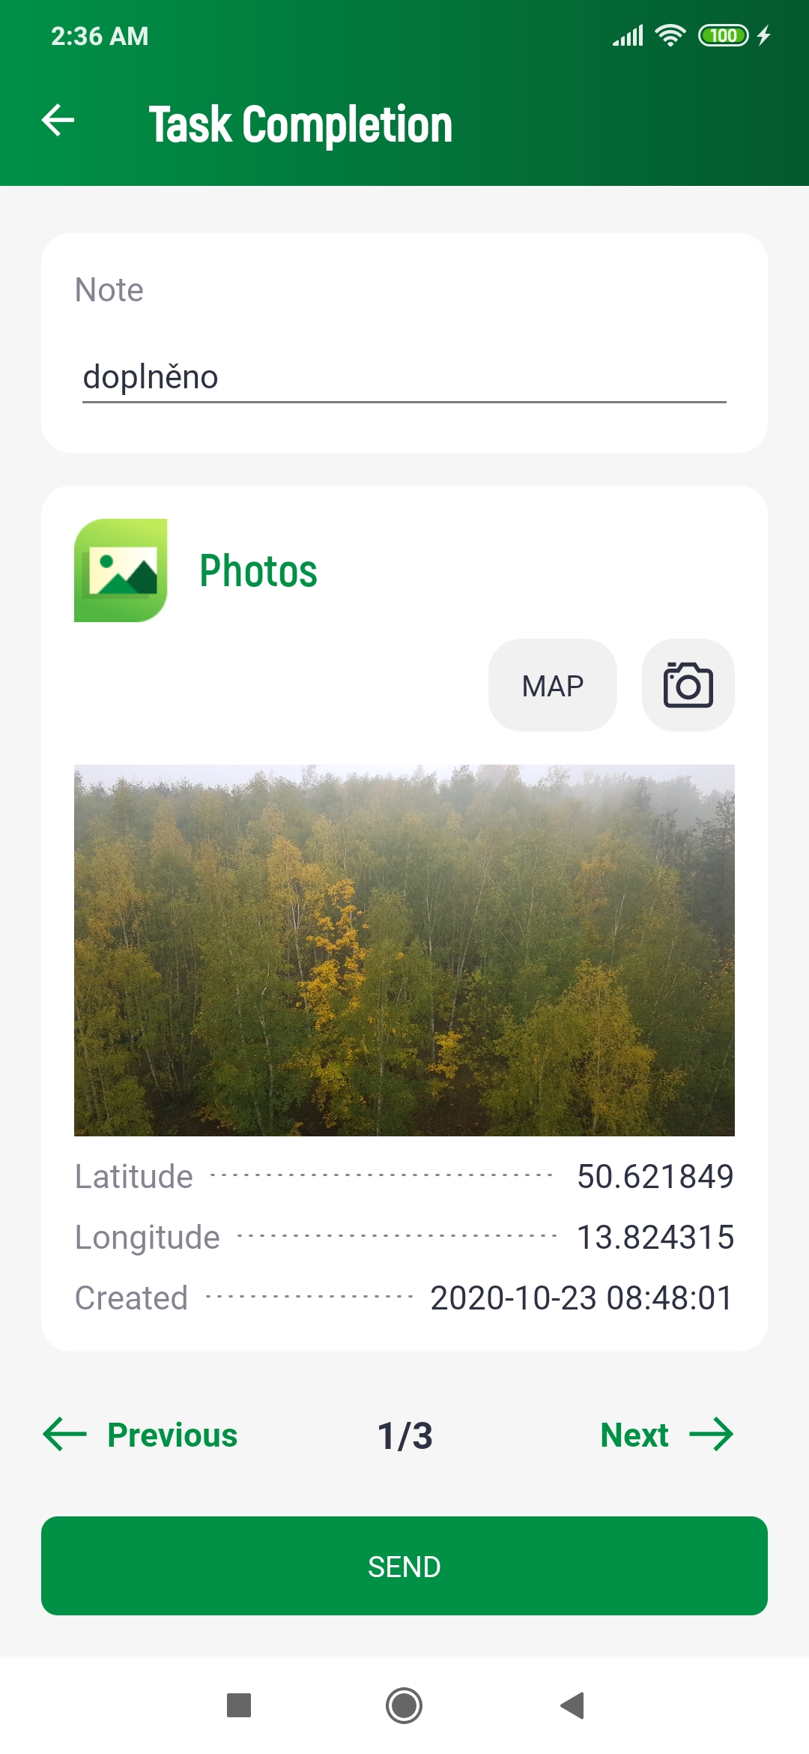. While taking a photo, the user will see a countdown on the screen indicating how long they need to stay in one place to take an accurate geotagged photo.

Tasks and photos can only be edited until they are sent to the server.

To take photos that are not linked to an existing task, the *Unowned photos* screen contains a list of photos. A new photo can be taken using the  button. By pressing *Send*, all new unsent photos will be sent to the server.

## Tracking a path

The *Map* screen allows the user to track a path and calculate an area. The user’s actual position will be shown in the form of a blue dot, while the current position calculated from GNSS data through the Convex Hull algorithm is marked with a red dot.

To track a path, press the *RECORD* button, insert a name for the track if desirable, and confirm. To end the path tracking, click the *STOP* button. A polygon will be automatically created as the first and last point of the track are connected. Information on the tracked path and polygon include the calculation of the area within the track.

By pressing PATHS button, a list of recorded paths will be shown. Here, the user can select a path to draw.

# Mobile application – iOS

This Quick Start Guide provides a brief overview of the main functionalities of the EGNSS4CAP iOS application. Detailed information on the functionalities of the application can be found in the EGNSS4CAP User Manual.

## Getting started

The EGNSS4CAP application will be distributed by the App Store (testing via TestFlight):

* Make sure to grant permissions to access the device’s location and take pictures:
  + Access device’s location
    - Allow to add location data to token photos.
    - Receiving different types of location data
    - Recording paths.
  + Take pictures and record video
    - Allow to take photos by camera.
* To log in to the application, connection to the internet is required. After the first login, the user will be remembered. A new login will only be required after explicit logout.

## Main menu

On the main screen, information on the user’s device is shown, including the capability to receive location data. If any of the traffic lights are red or yellow, the device does not have the indicated capability.

The application modules can be accessed through by pressing buttons which are situated in the bottom of the screen. Following options are available:

* Photos
  + Open screen with list of unowned photos.
* Tasks
  + Open screen with task list.
* Map
  + Open screen with map including all captured photos, recording new paths or viewing already recorded paths.
* Settings
  + Open screen with settings.
* About
  + Open screen with basic information about application

## Taking a photo

In tasks the user can see their tasks by names, statuses, number of photos, date of creation and due date. By clicking on the task row, the task completion screen is opened.

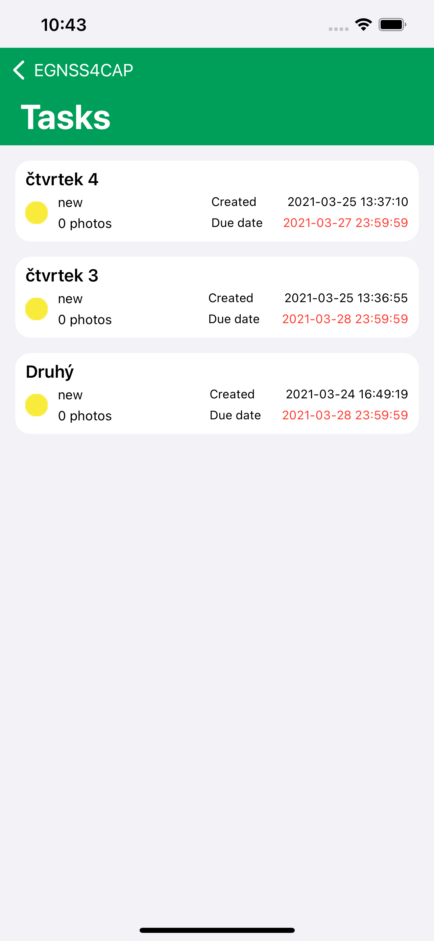

Image 2 Tasks

When clicking on a task, the user will be directed to the Task Completion screen. For each task, the Paying Agency administrator can give *Instructions*, indicate a *Reason for Return* if the task has been returned to the user for additional information.

The user can provide the Paying Agency with information in the *Note* section.

Users can take a geotagged photo by clicking on the camera button . While taking a photo, the user will see a countdown on the screen indicating how long they need to stay in one place to take an accurate geotagged photo.

Tasks and photos can only be edited until they are sent to the server.

To take photos that are not linked to an existing task, the *Photos* screen contains a list of photos. A new photo can be taken using the *New* button. By pressing *Send* in *Photo detail* screen unsent photo will be sent to the server.

## Tracking a path

The *Map* screen allows the user to track a path and calculate an area. The user’s actual position will be shown in the form of a blue dot.

To track a path, press the *RECORD* button, insert a name for the track if desirable, and confirm. To end the path tracking, click the *STOP* button. A polygon will be automatically created as the first and last point of the track are connected. Information on the tracked path and polygon include the calculation of the area within the track.

By pressing PATHS button, a list of recorded paths will be shown. Here, the user can select a path to draw.

# Web Interface

This Quick Start Guide provides a brief overview of the main functionalities of the EGNSS4CAP Web console. Detailed information on the functionalities of the web console can be found in the EGNSS4CAP User Manual.

## Getting started

The web console is available at <https://egnss4cap-uat.foxcom.eu/login.php>.

The user will be asked to provide a valid login.

## User (farmer) interface

After login the *Tasks* screen will be show at first (Image 3 Tasks).

On the left side, the farmer’s tasks are shown. They can be sorted and filtered. On the right side, a map with tasks is shown.

This screen provides the following functionalities for the user to check the information they have provided through the application:

1. Open task detail (by pressing task row in task list)
2. Find task by text
3. Filter tasks by status (by pressing on status)
4. Sort tasks by chosen column
5. Show screen with unassigned photos – *Show unassigned photos*
6. Show screen with path – *Show paths*

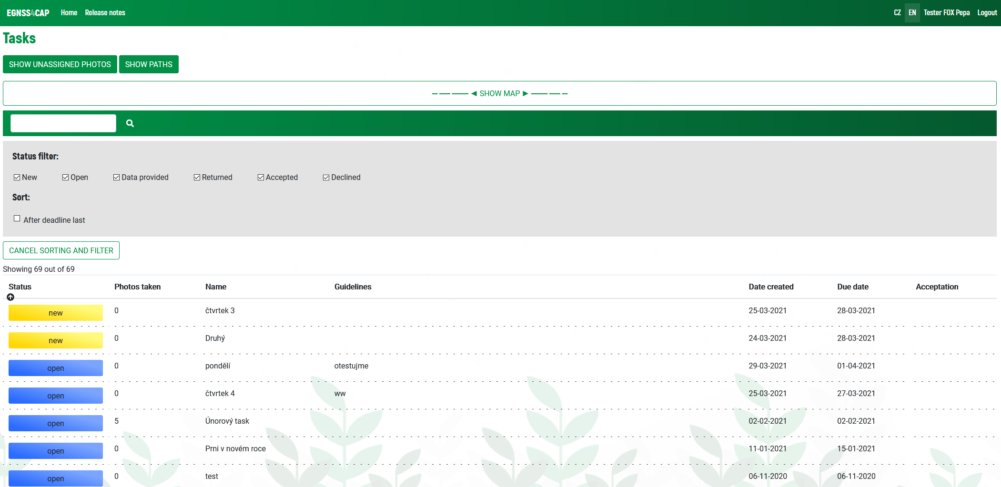

Image 3 Tasks

Unassigned photos can be further edited by rotating, deleting or selecting for task assignment. To facilitate the work of the user, these actions can be performed in bulk as well.

## Administrator (Paying Agency) interface

The administrator has access to two separate functionalities:

* User management
* Task management

### User management

1. Search farmer by text 
2. Sort farmers in list by selected column
3. Open farmers detail
4. Add new farmer
5. Edit selected farmer
   * If the password remains empty, it will remain unchanged

### Task management

1. Add a new task
2. Batch tasks accepting
   * By selecting tasks (checkbox at the end of row) and pressing *Bulk accept*
   * Tasks with status “data provided” can be only accepted.
   * By accepting a task, the status changes from “data provided” to “data checked” and acceptation will change to “Accepted”
3. Task detail: accepting , rejecting , returning the task to the farmer , or indicating that data are provided , deleting the task 